**Project Design Phase-II**

**Data Flow Diagram & User Stories**

|  |  |
| --- | --- |
| Date | 14 APRIL 2025 |
| Team ID | SWTID1742640402 |
| Project Name | MyRide |
| Maximum Marks | 4 Marks |

**1. Data Flow Diagram (DFD)**

* **External Entities**:
  + Passenger
  + Driver
  + Payment Gateway
  + Admin
* **Core Process**: Cab Booking System
* **Data Flows**:
  + Passenger → Booking request → System
  + System → Driver assignment → Driver
  + System → Payment confirmation → Payment Gateway
* **Processes**:
  1. Book Ride: Passenger submits pickup/destination → System validates → Generates fare estimate.
  2. Assign Driver: System matches nearest driver → Sends notification.
  3. Process Payment: System confirms payment → Updates booking status.
  4. Track Ride: Real-time location sync between Driver ↔ Passenger.
* **Data Stores**:
  1. User Database (Passenger/Driver profiles)
  2. Booking Database (Ride details)

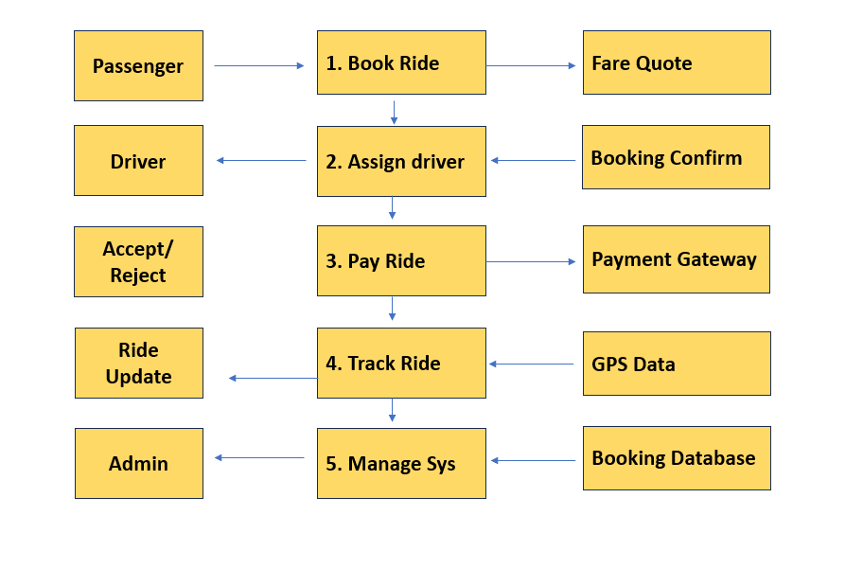

**User Stories :**

